Save Bronze Recipe Cookbook to desktop. When you double click on book, Master cook will open.

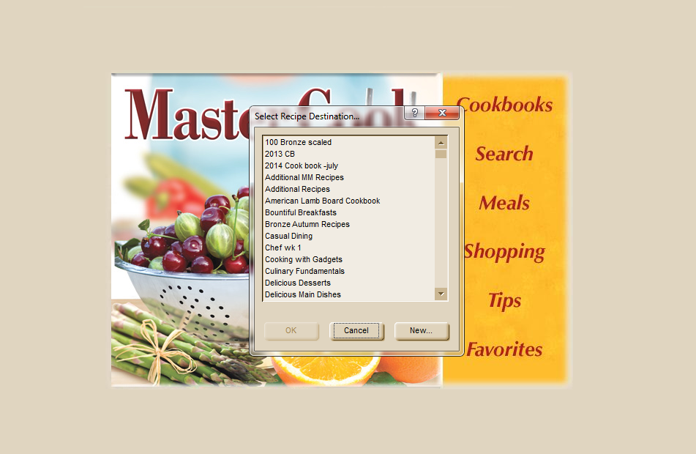

Select new and type in name and import cook book into the newly named cook book. By using the "new” option the program will create a location for the book to be stored within the Master cook program.

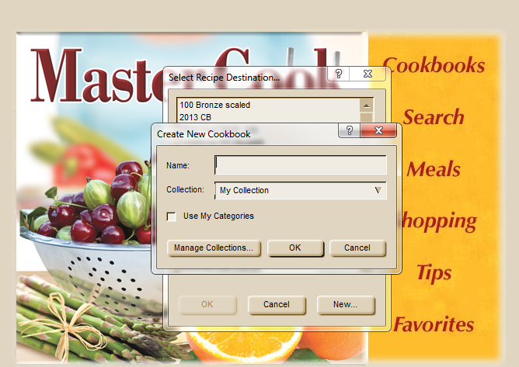

Once you have named your new cook book select ok and your cook will be store and accessible in that cook book

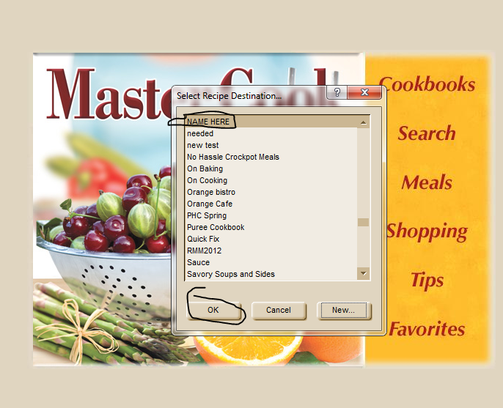

When you have finished importing the cook book, delete it from your desktop

