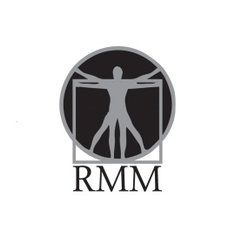 Resident Menu Manager
A. INSTALLING YOUR RESIDENT MENU MANAGER SOFTWARE
Information needed to set up account and for any users
- Name :First and Last
- E-mail: complete e-mail address
- All users will have default password as :password
Send information to: toczekw@earthlinklink.net

- Log into: www.innovaservices.info
- Click on “click here” next to RMM Login. See highlighted picture below.

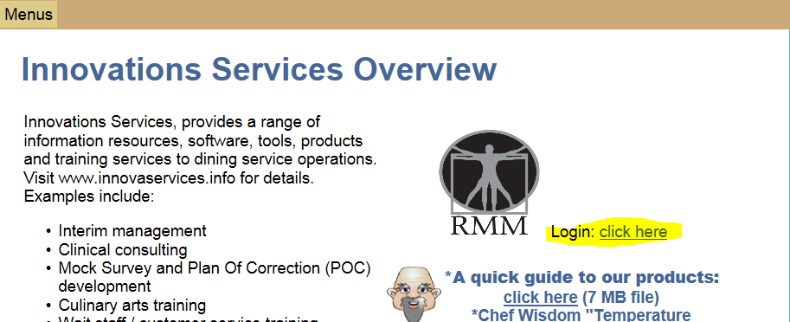

- Once you are logged into RMM, put in your user name and default password: password to log in. See highlighted picture below.
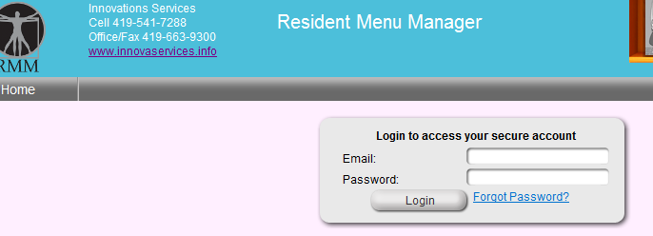

- Create a shortcut on your desktop by clicking and highlighting the address on the address bar and either a.) drag it to the desktop or b.) copy the highlighted address with a right click of your mouse, then position your mouse on your desktop and paste it there with another right click of your mouse. See pictures below.
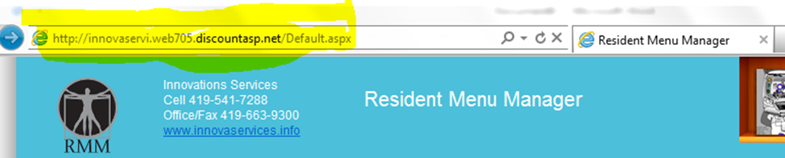

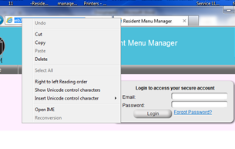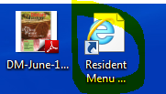
After this process is complete, you will be able to access the program directly from your desktop. If you are at a diffeerent computer, simply log into the website for InnovationsServices: www.innovaservices.info and login as you did above.

The complete User Manual and Diet Manual are available on the computer as well as an assortment of customer satifaction surveys in PDF form.

Note:
Remember the Master Cook Program is needed to access the cook book and create, scale or edit recipes.

B. SETTING UP YOUR RESIDENT MANAGER PROGRAM
- You will receive a link to download your program from Box.net, follow the link and down load the file.
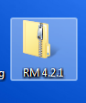
- In order for the program to install correctly you must open the zipped file and copy or drag the file to your desktop.
- Once saved open the file and run the setup and follow the installation wizard. The Instruction manual for Resident Manager is available also in the folder.
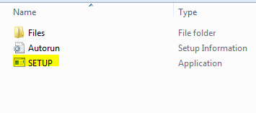

C. IMPORTING YOUR RESIDENT DATABASE INTO YOUR RM
- Your resident database will need to be converted to the format used for Resident Manager. All data entry to convert the database is done by Helen Esbenshade. Therefore, any requests for data entry of resident database information should be sent to her e-mail at helenesbenshade@yahoo.com with a copy to Wayne Toczek at toczekw@earthlink.net as a double check to ensure the request is received and followed up on. Please include contact information of whom Helen should communicate with. If you do not receive some confirmation from Helen that the request has been received, please feel free to contact her by telephone at (419) 744-0689.

- Once a request is received by Helen, she will respond with an email attaching 1.) this instruction manual, and 2.) a sheet titled “Resident Manager – customizing your data” that shows what information is needed from the facility in order to get the resident information converted into a database for the Resident Manager program. Once Helen has completed conversion of the database, she will send it to you in a file as an attachment to an e-mail to upload into the program. The following steps will walk you through the process of uploading the database into the Resident Manager program. If you have any questions throughout this process, please feel free to contact Helen at this email address, helenesbenshade@yahoo.com or call her at telephone number (419) 744-0689.

- When your resident database is complete and ready to be imported, you will receive an e-mail from Helen with the database file attached to it. Download the attached database file (which will be named “Resident Manager [current date] [name of your facility].MDE”) to your desktop or another location on your computer where you will be able to locate it easily.

(In some cases, systems block the file and will not allow it to download to the system. If this happens, just inform Helen and she will have the file sent to you via a link to Wayne Toczek’s box.net and you would follow the link to your database file, and similarly, save the file onto your desktop or another location on your computer where you will be able to locate it easily.)

- Open Resident Menu Manager.

- Click on the Database Utilities icon, select restore. (See below).

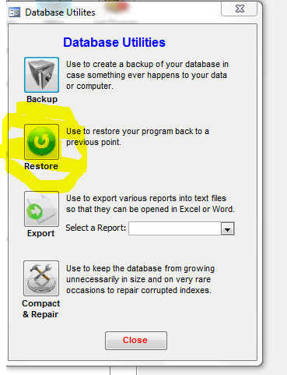
- Locate the database file that you just saved from the box.net link onto your computer: Resident Manager [current date] [name of your facility].MDE and select open. (You will see the warning, “All data in the current database will be replaced with date from “…Resident Manager [current date] [name of your facility].MDE. Are you sure you want to proceed?” Click on Yes and the resident database will be imported into your Resident Menu Manager. (See below).

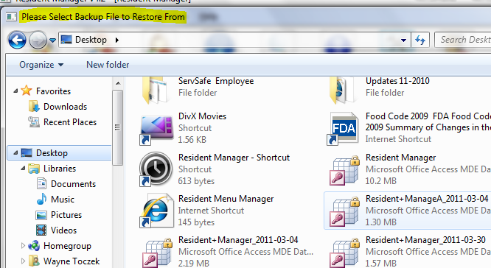

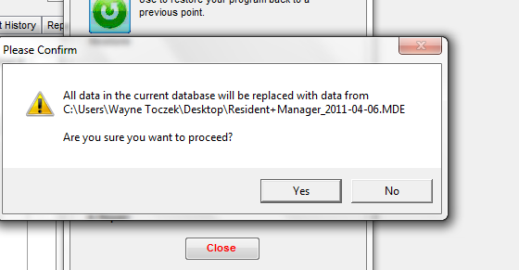

Note: Under the “Customize data” icon, the password is: password.

Go to reports and do a printout of residents by name in the Other Report tab to check your data.

D. UNINSTALL AND REINSTALL OF RESIDENT MANAGER PROGRAM

From time to time, for various reasons, a software program may experience problems or be corrupted. If you should experience a problem with your Resident Manager Program and need to reinstall a clean version, follow these steps:

- Backup your current resident database information -

From the Database Utilities menu in Resident Manager, click on “Backup” to create a backup of your resident database.

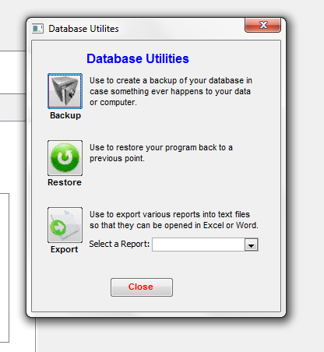

(*This enables you to save a copy of your resident information to date. Then once you have reloaded the software, you can upload the backup of your resident information back into the program rather than needing to re-input all that information.)

To ensure that you have a good database that you can use later to upload back into the clean version of the program, it is suggested that you back up the information to two separate places. For example, save one copy somewhere on your hard drive or desktop and save another copy to a jump drive.

- Uninstall the Resident Manager File from your computer -

First, locate the Resident Manager file where it is installed on your computer. (*This is a file folder. You are not going into the software application.) This folder should be saved as a shortcut icon on your desktop, labeled something like “RM 4.2.1.” Click on this shortcut icon.

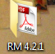

***If there is not a shortcut icon on your desktop, see if you can locate the Resident Manager file folder in your computer’s program file lists. Click on “Start”, then “Computer,” then look in the drive where you store your programs. This will be your hard drive, i.e. “Local Disk (C:)” or it could be a network drive that your company uses, i.e. (D:), (F:), or whatever drive is designated by your company as its network drive. Click on that drive and locate the “RM 4.2.1” file folder. IF YOU DO NOT HAVE A RESIDENT MANAGER FILE FOLDER SHORTCUT ICON ON YOUR DESKTOP AND ARE UNABLE TO LOCATE IT ON YOUR COMPUTER, CONTACT INNOVATIONS SERVICES TO HAVE THE FILE FOLDER SENT TO YOU.***

Once you are in the “RM 4.2.1” File Folder, select “Utilities.”

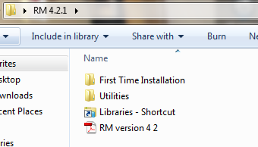

Under “Utilities” will be an application file titled “WindowsInstallerCleanup.” Double click on that file and run through the process, hitting “Next,” “I Accept License Agreement,” “Next” and when the process is done hit “Finish.” This installs the cleanup file on your computer.

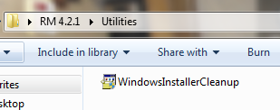

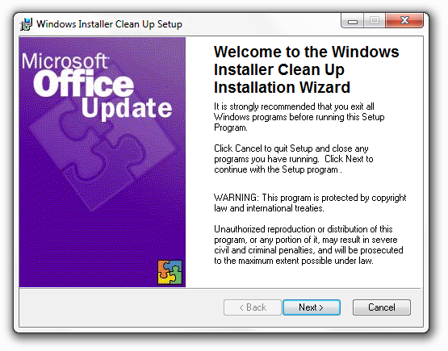

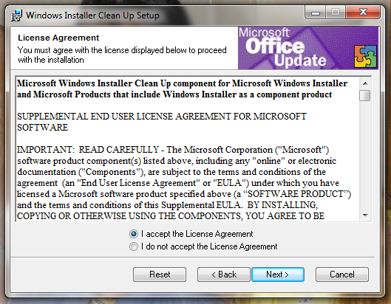

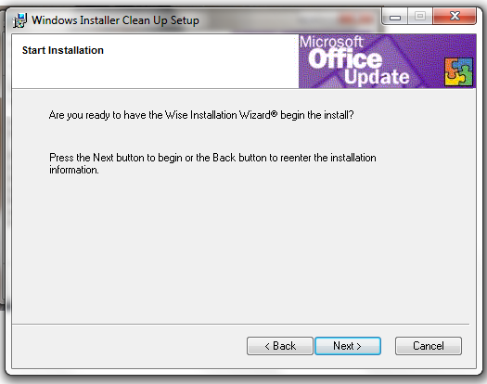

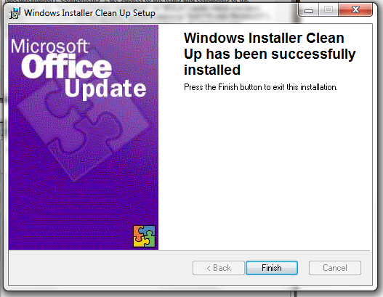

Now that the cleanup file is loaded onto your computer, go back into the “Startup” menu and select “All Programs.” From the list of programs, double click on “Windows Install Cleanup.” This will bring up a list of programs. Scroll through the list to locate the “Resident Mgr v4.2.1” file and click on it to highlight it. Then select “Remove.” This will remove the program from your system. (*The only exception to the file name would be if a newer version were installed on your system, i.e. if not “Resident Mgr v4.2.1, it may be Resident Mgr v4.2.2 or v4.3.1, etc.*)

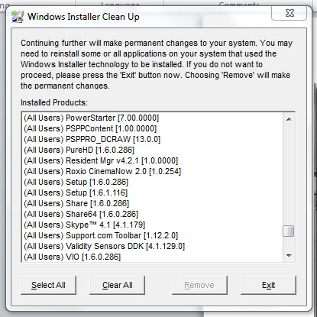

***If there are any icons to Resident Manager left on your computer, delete them at this time. They are no longer valid icons. A new icon will be put onto your system when you complete the reinstall.***

To remove the Windows Installer Clean Up Program from your system, simply go back into the “RM 4.2.1” File Folder, and again select “Utilities,”

And rerun “WindowsInstallerCleanup.” This process will be two steps and will remove that program from your computer.

- Reinstall the Resident Manager program to your computer -

Refer to Sections A, B and C of this document to reinstall the Resident Manager Program and restore your resident information database back into the Program.

